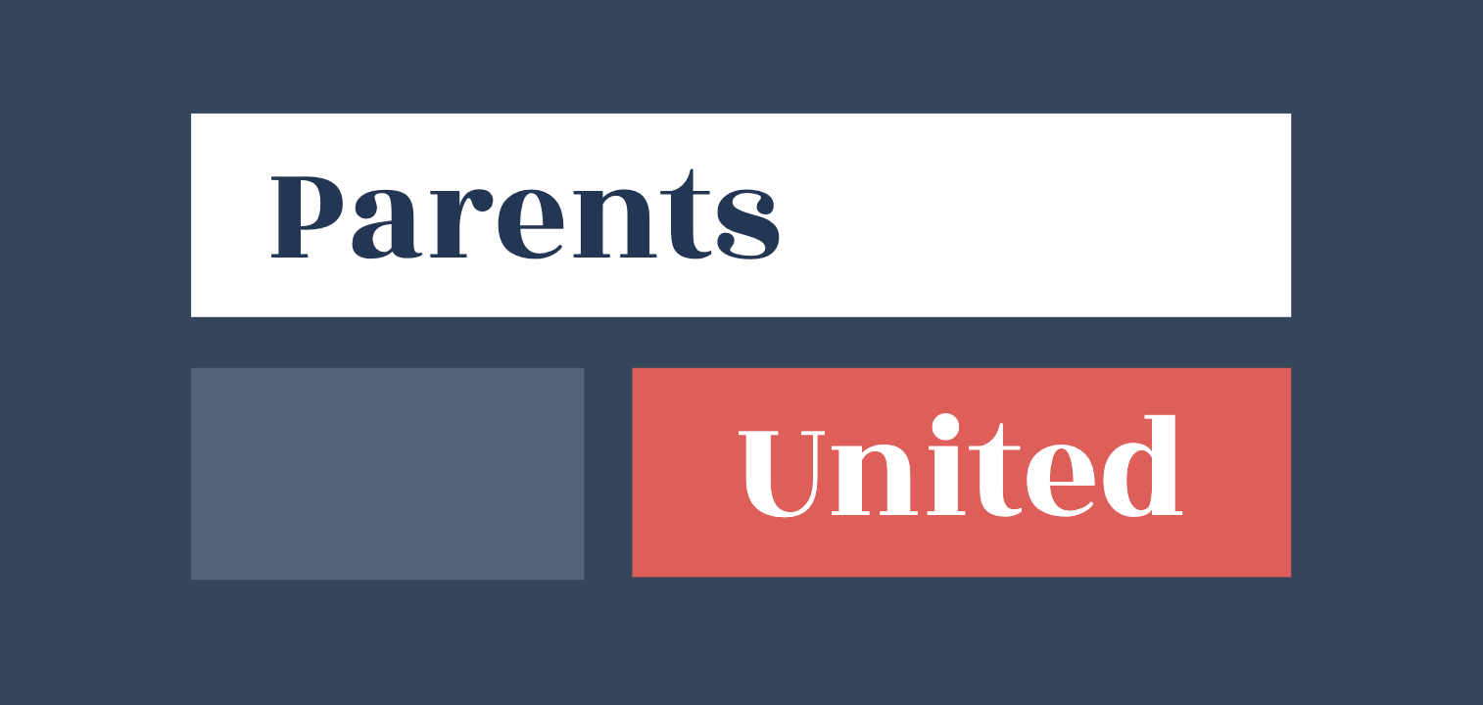

May 21, 2021

Dear AISNE and NEASC,

We would like to schedule an immediate meeting to discuss the concerns outlined in our letter to you earlier this month. While we acknowledge your written response, it is highly unsatisfying as you have not come close to addressing any of the concerns of this rapidly growing group which now numbers in the thousands.

We propose to engage in discussions with you with an open mind about the solutions to our concerns. We look forward to discussing with you our proposals, which include standards that require transparency around diversity of thought which is sorely lacking today. Please understand that our concerns are real and will not be placated by quotes from written standards which have become little more than empty promises. We cannot continue to watch children and students at your schools be shamed, ridiculed, singled out and targeted because they don’t follow “popular” opinions.

Please advise us of the next available time to meet.

Thank you.

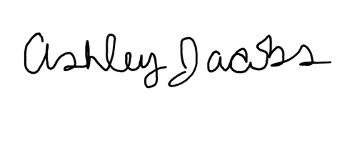

Ashley Jacobs

On behalf of Parents United